AI and Society
Water Potability Predictor

1. Abstract
The objective of this project is to provide a machine learning solution for ensuring that the safe drinking water supply can be ensured. This solution corresponds to the UN Sustainable Development Goal of “Clean Water and Sanitation”, conventional methods based on lab tests are generally time consuming and reactive, with the maximum duration of 72 hrs for test results, the proposed solution helps achieve immediate predictions about potable water by utilizing various physical & chemical characteristics, The application of the support vector machine algorithm based on the database of 3,276 samples provides an automatic prediction solution via a Streamlit interface.
2. Problem Definition & Methodology
2.1 Problem Definition
Water is a basic need that everyone requires , but unfortunately , there are many areas around the world that experience variations in their water quality due to industrial waste , weather changes, & lack of proper drainage systems , major problem is associated with time factor and high price of conducting static tests in laboratories ; Therefore ,now we plan to use AI based system for real time classification.
2.2 Dataset Description
The experiment is carried out using the “Water Potability Dataset” from Kaggle.;
• Sample Size: 3,276.
• Variables: 9 vital parameters of water quality that the machine learning model is going to consider include: pH, Hardness, Solids (TDS), Chloramines, Sulfates, Conductivity, Organic Carbon, Trihalomethanes, and Turbidity.
• Dependent Variable: Potability. 1 = fit for human consumption,
2.3 System Workflow
1. Data Preparation: Addressing any missing data with imputations and scaling data using the StandardScaler to make sure that all inputs are consistent for the model.
2. Model Training: Running various models, such as logistic regression, random forest, gradient boosting, and SVC, which yielded the best model for production;
3. Exporting Models: Exporting the best_water_model.pkl and scaler.pkl using joblib;.

3. Results and Model Performance : -
Support Vector Machine was chosen because of its capability to analyze relationships in environmental data. Recall (Sensitivity) for the "unsafe" class was considered the main criterion in the model assessment process in order to focus on people’s health protection.
• Libraries used: Pandas, NumPy , Scikit-learn , and Seaborn ( Visualization .
• Pre-processing: Feature transformation was performed by applying StandardScaler.
4. Implementation and Deployment :
In order to connect AI modelling to its practical application a interactive dashboard was implemented using the Streamlit platform.
4.1 Technical Design
• Back-end: The prediction algorithm written in Python that imports the SVM model and scaler exported from the model.
• Front-end: The application has a friendly user interface with input fields for metric parameters (e.g., pH value, conductivity).
• Prediction Engine: When pressing the "Predict Potability" button, the application scales the input data and delivers a prediction.
4.2 Application Functionalities
•Timely Prediction: On-the-spot feedback about water safety depending on manually entered metric values.
•Specialized Interface: Implementation of CSS style for hiding default Streamlit menus.
5. System Demonstration & Functional Explanation
The transition from a static machine learning model to a functional tool was accomplished with a custom built interactive dashboard , this section describes how system works in a live environment…
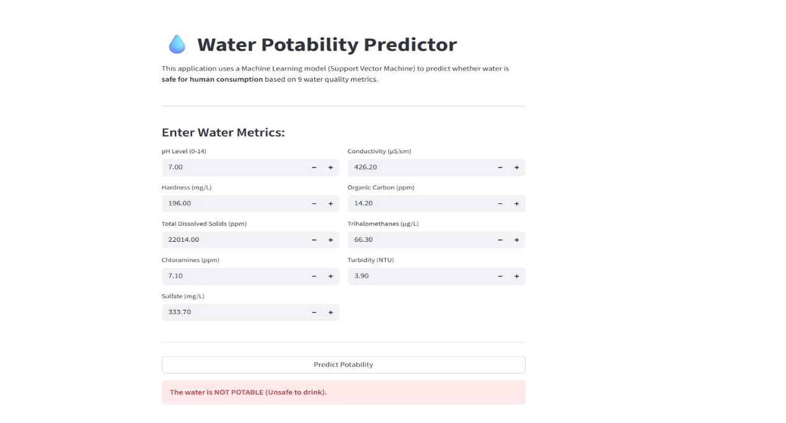
5.1 User Interface Design
The demonstration platform built using Streamlit & connects complex mathematical weights with the end user ; The interface is divided into two main areas : -
• The Input Sidebar / Field : users enter real time data for nine chemical and physical parameters , such as pH , sulfates , and turbidity .
• The Prediction engine : when user activates " Predict Potability" function , system runs a backend script that retrieves the pre trained Support Vector Machine (SVM) weights .
5.2 Process Flow :
When user inputs a value , system does not process it in its raw form, water metrics like "Solids," measured in thousands , & "pH ," measured on a scale of 0 - 14, have different magnitudes . Therefore , demonstration includes a Standardization Step , he input goes through the scaler.pkl file , allowing model to view data way it was trained.
output is binary but has user friendly interpretations : "Safe" result appears in green , "Unsafe" prediction triggers warning. this visual feedback loop shows how AI can turn complex laboratory data into a clear "go/no-go " decision for water consumption..

6. Societal Impact & Ethical Discussion
The use of AI driven water assessment tool has important effects on public health and social fairness. It closely connects with the United Nations Sustainable Development Goals (SDG 6 and SDG 3);
6.1 Democratic Access to Safety : In many developing areas, " digital divide" adds to a "safety divide " laboratory testing is often only available in urban centers or to wealthy industrial sectors, our project shows a way to make safety accessible to all by offering a software based option , we aim for a future where a field worker with a smartphone and basic testing strips can get a top level safety assessment without needing a PhD or an expensive laboratory.
6.2 Proactive vs. Reactive Healthcare : The typical method of water monitoring focuses on detecting problems after infection occurs , communities often realize their water is contaminated only after surge in hospital admissions, societal benefit of this AI model lies in its ability to prevent problems, It allows for frequent testing , enabling authorities to notice subtle changes in chemical patterns, such as a specific drop in pH combined with rising conductivity; , before it leads to a health crisis..;
6.3 Ethical Responsibility in AI: We recognize that no model can be 100% accurate , our system is designed to prioritize Recall. In a social context, a "false alarm" ( labeling safe water as unsafe ) is a minor issue , while a " missed detection" (labeling toxic water as safe) can be life-threatening, by focusing the model’s logic on public safety rather than just pure accuracy, this project highlights the ethical use of AI in areas that affect people’s lives.

7. Conclusion
The development of the Water Potability Predictor proves that machine learning can be incorporated into the monitoring of environmental health effectively through the transition from laboratory analysis of the water's potability to its predictive ability through machine learning algorithms, an efficient early warning system can be established, ensuring maintenance of healthy living .

